2582 Railway - various posts from third parties

‘There was only the train at one time, no buses, but by the 1960s everyone had a car and there were plenty of buses. The train was losing money.
Contributed by Phyllis Shepherd (née Washington, born 1907), December 1999

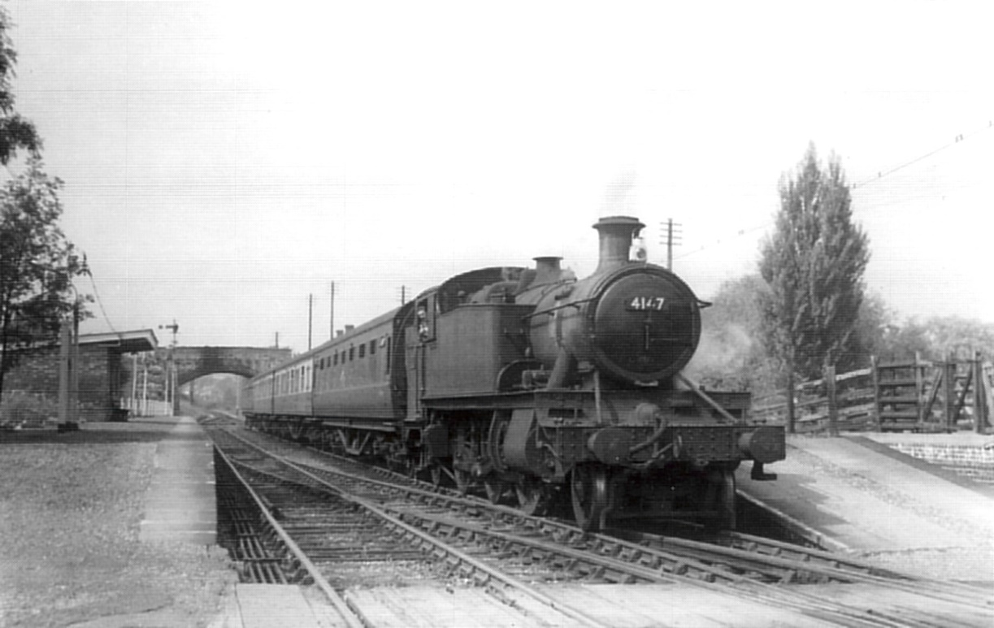Princes Risborough-bound train of four carriages at Wheatley, August 1959. Wartime hospital trains at the same platform were three times the length. (Harry (D.H.) Cowan).

‘My father, Arthur Bunce, was a platelayer, a linesman on the length between Tiddington and Horspath Halt. Twenty one years he had with GWR before injury. Every year he filled his cap with the first spring violets from the railway embankments and brought them home for my mother. He also brought home the rabbits killed by the train. We ate a lot of rabbit. When a pheasant was killed the men drew straws for it. There were plenty of snakes on the railway banks—one day they were cutting the grass on the slope by the Tunnel and down rolled a ball of mating snakes—the men fled! One snake even fell out of Dad’s jacket when he put it on after a lunch break.

‘In winter he used to go out ‘fogging’ with detonators and ‘snowing’ with a shovel. He’d get up at night in bad weather to go out and check the line. After the bomb fell in 1940 they had to shore up the line because of the hole by the embankment. They thought it was an attempt to bomb the rail bridge over the A40 and bring it down on the road as well. The A40 was called the ‘gateway to the Midlands’.

‘On Jubilee Day, 1935, there were no trains and the line was clear. Dad told me to get on my overcoat and we two children, Tommy White and myself, went with our two dads on the linesman’s trolley. We went from Wheatley to Tiddington turntable, back through to Horspath Halt where there was a turntable between Horspath and the Works, and then back to Wheatley. Right through the Tunnel we went and we needed our coats! The trolleys were kept in a shed just beyond the Signal Box. There was a Buster Keaton-type trolley there, too, with an up-and-down handle.
Contributed by Olive Gee, née Bunce, December 1999.

‘Big engines were everyday occurrences during the 40s and early 50s. Some trains worked through from Paddington to Oxford (and possibly beyond) in those days and everything except the very heaviest GWR engines (6ooos and 4700s) could be seen at Wheatley. At night there was a heavy traffic of freight, some of it hauled by 28XXs (heavy goods 2-8-0s) and I have seen ‘Castles’, ‘Stars’, ‘Saints’, ‘Halls’,‘Granges’ all at Wheatley and travelled behind some of them. One magnificent day there was an accident on the Oxford to Didcot line and all through traffic to and from London and Oxford came up the line. There were three trains in Wheatley station at a time.
Contributed by Harry (D.H.) Cowan, December 1999.

Contributions to this post were received from
Sue Newell says:
4th February 2013 at 10:19 am
I can remember the railway in the 1960’s, I went to school with the daughter of the last station master. Mr Kimber. We used to stand with him on the platform waiting and watching the trains into Oxford.

Molly Morris says:
15th July 2013 at 11:23 am
Every night around midnight we heard the train hooter as it left Wheatley station, the children loved travelling from Wheatley to Oxford on the train. Such good memories.

Peter Alexander says:
18th April 2014 at 3:38 pm
Used to see the trains across the road from the windows of Wheatley Secondary School. Regular passenger services had ended, but frieght still continued until about 1967. After that there were no more trains and I made up an attachment to enable my bicycle to ride the rails. Great fun for a year or so riding as far as Cowley in one direction and Thame in the other. Then in 1969 they started to remove the track.

Pat Hartride says:
29th April 2014 at 4:38 pm
We moved to a newly built bungalow on Old Road at Easter 1960. I worked in Fleet Street and my husband at the Oxford Mail. I travelled up to London via Wheatley and Princes Risborough, running along the railway track to the Station. There were only about 4 passengers on the train (children going to school in Thame I believe).
Often I would return on one of the two evening trains and my husband would board it to travel to Oxford to report an event. After our first son was born we would go to to Oxford to shop at Oxpens market ( all of us in the guard’s van).
When we moved to Kelly’s Road in 1965 the track ran behind our house and the whistle would sound a few times a day to warn anyone of the goods train crossing the track between Littleworth and Wheatley.

Phil Quarterman says:
14th December 2019 at 7:04 am
I lived on Crown Road, not far from the station. I was crazy about steam engines and all things railway. Every time I heard a whistle I would run up the alley from Farm Close as fast as I could to see the train. I spent hours in the signal box with the signalman pulling levers and working the tokens. Me and my friends would hang around for the morning freight train and ask the crew if we could go up in the cab. Sometimes they even allowed us to ride while they shunted in the yard. I even took a turn on the throttle. All totally against regulations of course. We constantly had to avoid Mr. Kimber, the stationmaster.

Michael Heaton says:
15th December 2019 at 7:10 pm
Fascinating and just the type of ‘memory’ which we need for a Wheatley History publication being planned.

alison quainton says:
5th July 2020 at 7:45 pm
I have just told my daughter, about the time, mum, my aunt jane, maybe a brother and myself, went from Wheatley to Thame by train,[by the way I was only about seven] and my aunt asked me ,when we got off of the train in Thame, if I liked it, and I said that, I had been on a train before. She must of thought it was my first time on board. We lived at Forest Hill then and I still like to be able to travel by steam train if I can.

