Shotover Hill and Country Park

Shotover Dawn
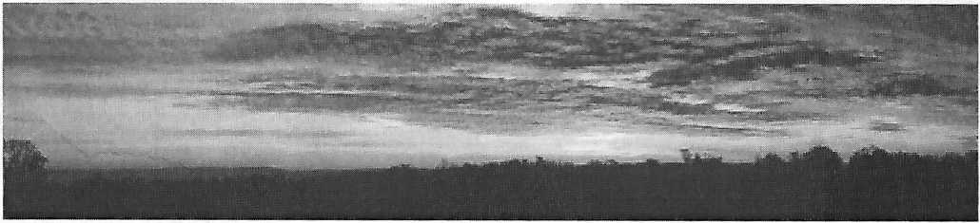
(A panorama covering approximately 180 degrees, assembled from six photos, taken June 1998)

Shotover Hill and the Old Road
Shotover Hill, 3 miles (5km) to the east of Oxford, rises steeply to a height of 557 feet (171m) above sea level. Indeed one theory of the origin of the name Shotover is from the Old English Scoet Ofer, meaning a steep slope.
Shotover was a Royal Forest from the time of the Domesday book until 1660, by which time the woodland was in such poor condition that it was disafforested or made no longer subject to forest laws.
Throughout its time as a Royal Forest the road from Oxford to London ran over the top of Shotover Hill. Up to the middle of the sixteenth century the main users of the road would have been pedestrians, riders and pack horses. The Highways Act of 1555 made parishes responsible for the upkeep of roads within their boundaries. In the Oxford area, increased traffic placed a heavy strain on the roads leading into the town and this resulted in the Mileways Act of 1576. This bound inhabitants living within 5 miles of Oxford to supply labour proportional to their holdings, to maintain the roads within one mile of the city centre or "mileways". However the road over Shotover was outside this one mile limit and so did not benefit from the mileways act. Its maintenance remained the responsibility of the parish.
By the seventeenth century wheeled carts and waggons were starting to replace packhorses, and carriages were coming into use for people making longer journeys. In 1669 the diarist Anthony Wood reported that on Monday April 26th, the first "Flying Coach" was able to complete the journey from Oxford to London within a single day. It set out at 6 am from All Souls college and set its passengers down at their inn in London by 7 pm.
This increase in wheeled traffic took its toll on the roads and by 1647 parishioners with the misfortune to have a "main road" passing through their parish were arguing that taxes should be levied on road users to fund the upkeep of the roads. The result of this was the first of the Turnpike Acts, passed by Parliament in 1663. This permitted local justices in Hertfordshire, Cambridgeshire and Huntingdonshire to levy tolls on traffic using the important road Ermine Street, where it passed through those counties, in order to cover the costs of keeping the road in good repair.
The idea of making road users, rather than parishioners, pay for road maintenance caught on slowly over the next 30 years. The early "Justice Trusts" were replaced by Independent Trustees, who were granted powers to borrow money, appoint officers, manage the roads and levy tolls to pay for their repair. The trustees themselves were unpaid and specifically forbidden from making a profit from the activities of the trust. However most were local business men who benefitted indirectly from the increased trade brought to a town with good road links. The turnpike system grew steadily over the next 150 years until by 1838 when the turnpikes were at their peak, it has been estimated that there were more than 1000 turnpike trusts, responsible for around 22,000 miles (35,000 km) of highway. This represented around one fifth of all the public highways in the country.
The road over Shotover was made into a Turnpike by the Stokenchurch Turnpike act of 1719, the introduction to the act stating that the road had "become so ruinous and Bad, that in the winter season the said Road is Dangerous to Travellers”.
Presumably the act resulted in an improvement to the road, but the tolls charged were a source of much complaint. In 1740 the tolls were one shilling for wagons and carriages drawn by four or more horses, and sixpence for those with less than four horses; a lot of money at that time.
The Turnpike Act could do nothing to reduce the slope of the hill and the western escarpment in particular was so steep that travellers were forced to dismount from their coaches and walk up the hill. The resultant slow progress made Shotover a favourite haunt of Highwaymen. In 1737 for example, John Wesley was a victim.
In 1773 the trustees applied to parliament for powers to divert the road to a new route entirely avoiding Shotover. In 1775 a cutting was made up the steep face of Headington Hill making possible the opening of a "New Turnpike" to the north of the old road, passing through Headington and along the line of the present A40 road. However progress on the new road appears to have been slow, with disputes over the exact route and a shortage of funds to build it. In 1788 the trustees went back to parliament with a request to enlarge the term and powers of the previous act in order to allow them to complete the new road. It was not until 1789 that the old route over Shotover was finally abandoned.
The new turnpike continued in use for another 90 years. The 1830’s were the heyday of the turnpikes when the volume of traffic was at its maximum. During the 1840's income started to fall as the railways began to take over the long distance traffic and the Stokenchurch road was finally dis-tumpiked in 1878.
After 1789, the road over Shotover fell into disuse. Little maintenance has been carried out since then and the description of 1719 is probably once more true! (Though nowadays travellers who venture over the hill are more likely to damage sumps and exhausts than to be attacked by highwaymen!)

The Country Park
Over the top of Shotover Hill, the old road is known as Shotover Plain. To the north of the Plain, the land is farmed but the Plain itself and the land to the south comprise Shotover Country Park. This land is open to the public and managed by the Oxford City Council.

